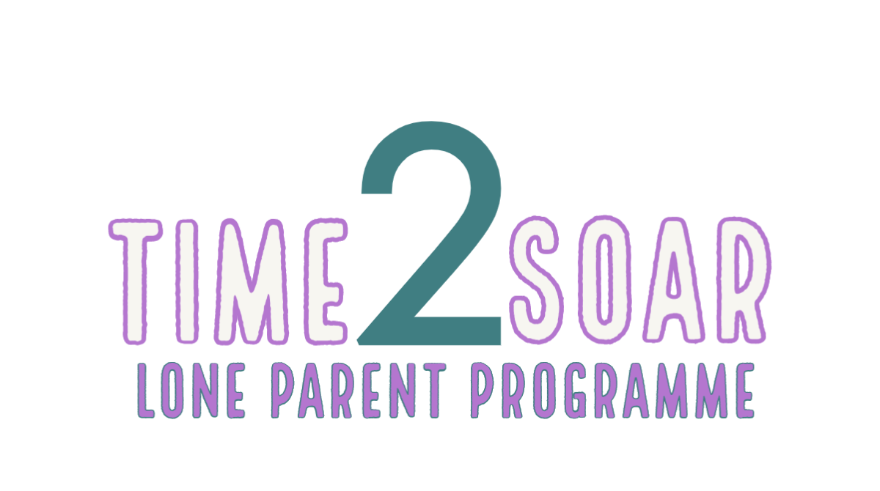

DELIVERED BY

THE WORKBOOK

Area of Learning: |  | Building Self-Awareness
Topic: |  | What do you want from us?
Section 1 | Reflection  What do you aim achieve from Time 2 Soar?
Section 1(a) | Reflection  Pick 3 of the most important things you aim achieve from the programme and answering the following question (try to pick different points to the ones discussed in session)  lklklkl | - What is the achievement?
 |  | - Why is that achievement important to you?
 |  | - How will this help you to achieve your goals?
 |  | - What is the achievement?
 |  | - Why is that achievement important to you?
 |  | - How will this help you to achieve your goals?
 |  | - What is the achievement?
 |  | - Why is that achievement important to you?
 |  | - How will this help you to achieve your goals?
Section 2 | Reflection  What Are Your Expectations Of The Time 2 Soar Team? | Your Expectations
Section 3 | Knowledge Checker | How many weeks will the programme last?
 |  | What will be doing on the programme?
 |  | What will we be doing to test your understanding of the programme?
 |  | How will the session on Expectations be run

Area of Learning: |  | Building Self-Awareness
Topic: |  | Who are you?
Section 1 | Reflection  Who am I? | To Me,  Love From,  Me
Section 2 | Reflection  How to connect with yourself?
Section 2 (a) | Reflection  How to connect with yourself? | Identify one way you connect with yourself now? And how it helps you with self awareness?
 |  | Choose one item from the brainstorm you would like to adopt after the session to connect with yourself and explain how you think it might help you become more self-aware:
Section 3 | Knowledge Checker | What key concept relates to our physical responses and how?
 |  | Why is it important to increase our self awareness?
 |  | Name 2 ways to connect with yourself
 |  | What is one thing we have learnt about ourselves from today's session?

Area of Learning: |  | Building Self-Awareness
Topic: |  | Expectations
Section 1 | Reflection  What are your expectations of your employer? | 10 Common Expectations Your Expectations  - Consistent  - Gives recognition and praise  - Offer opportunities to grow through training  - Provides a safe space for failure  - Demonstrates strong leadership skills  - Avoids micromanaging  - Put people first  - Remains honest  - Show dedication  - Demonstrates good problem solving skills
Section 1 (a) | Reflection  Pick 3 of your own expectations and explain why it is important that these expectations are met: | - Expectation and Reason
 |  | - Expectation and Reason
 |  | - Expectation and Reason
Section 2 | Reflection  Circle the keywords that make this person the model employee: | NEGATIVE ATTITUDE  DISHONEST  PUNCTUAL  UNWILLING  SELF DISCIPLINED  TEAM PLAYER  ALWAYS LATE  LAZY  MOTIVATED  HONEST
Section 2 (a) | Reflection  Choose 3 model employee keywords and explain how we can demonstrate these qualities at work:
Section 3 | Knowledge Checker | Name 2 things that make a ‘model’ employee
 |  | What is the name of the policy that allows us to make changes to our working hours?
 |  | What can happen if your child becomes sick?
 |  | When and how will the next session be available?

Area of Learning: |  | Careers and Training
Topic: |  | Why work?
Section 1 | Reflection  Think about your reasons for working. The career you would like and why.  Are your reasons purely financial, or is it more than that? | Write your thoughts in the space below
Section 2 | Reflection  From the thoughts in activity 1, what would you like to achieve, in the short term (next 6 months) and long term (2 – 3 Years) | Short Term  Long Term

Area of Learning: |  | Careers and Training
Topic: |  | What are the barriers to work?
Section 1 | Quiz  Directions: Indicate whether each statement is true or false. | T F  - Barriers are nothing more than a problem to be solved  - You should lie about a criminal history on an application or in an interview so that you aren’t screened out.  - Temporary jobs can provide you with valuable experience and supplemental income while looking for work.  - You don’t have to worry about finding housing, transportation, or childcare until you get a job.  - All barriers to employment come from factors outside of us that we can’t control.  - Effective planning can help overcome barriers.  - The last step in the career decision-making process is to take action.  - Employers are only interested in paid work experience.  - There is really nothing you can do to prepare for an interview.  - Ninety percent of the fastest-growing jobs require some kind of further education and training.
Section 2 | Reflection  What are the barriers to work? | Barrier Rank Suggestions for Overcoming  I don’t have reliable transportation.  I need a place to live.  I don’t have adequate childcare.  I need work that matches school hours  I don’t have enough money to live on.  I don’t know how to manage my money.  I need assistance with health problems.  I have problems controlling my anger.  I feel depressed most of the time.  I have low self-esteem.  I have a substance abuse problem.  I am too stressed to find a job.  I lack a sense of purpose or direction.  I don’t have any goals.  I don’t know enough about the jobs available.  I don’t know how to apply my interests to jobs.  I don’t know how to find job leads.  I don’t know how to write a good CV.  I don’t know how to interview for a job.  I don’t see the point in getting more education.  I can’t afford to go to college.  I don’t have a plan for my education or my future.
Section 3 | Reflection  What are the barriers to work? (cont.) | Try to think of 3 Positive things you can say about barriers to employment  1.  2.  3.  Try to think of 3 Negative things you can say about barriers to employment?  1.  2.  3.
Section 4 | Case Study | They [Jobcentre Plus] want us back to work but employers don’t want us because we’ve been out of work for so long and in theory don’t know what we’re doing anymore.  I’m hopeful for more interviews and I’ve done more application forms and sent out my CV and am waiting on those. It’s very disheartening; everyone wants someone qualified in some way. To get back into work means you’ve got to do some form of training in some area.
What advice would you give this person? Try to think of 3 things.

1.

2.

3.

Area of Learning: |  | Careers and Training
Topic: |  | How to overcome the barriers to work?
Section 1 | Reflection  Recast your current problems into proactive goals. | Define Issue (Identify Barrier) Look at ways to address (Research) Weigh up options Select Solution Act  Identify Barrier Possible Options Which would work better for me Preferred Option By When  1. 1. Y N  2. 2. Y N  3. 3. Y N
Section 2 | Reflection  Define Your Problem | Before you define a problem, it might feel vague or confusing. Writing out your problem will help to organize information, see it from new angles, and identify the most important issues.  When and where does your problem occur?  What are the causes of your problem?  Think about all the possible causes. Consider your own behaviour, as well as external factors.  Define your problem.  Be as clear and comprehensive as possible. If there are many parts to your problem, describe each of them.  TIP: If you find it difficult to separate your emotions from the problem, try to complete this step from the perspective of an impartial friend.
Section 2 (a) | Reflection  Develop Multiple Solutions | Write down at least three solutions to your problem. Without thinking about alternative solutions, we often get stuck on what worked in the past, or the first idea that comes to mind. There are usually many solutions to a problem, and our first ideas aren’t always the best.
Section 2 (b) | Reflection  Assess Your Solutions and Choose One | Begin by throwing out any solutions that are obviously ineffective or impractical. Next, look at your remaining solutions, and determine which ones are the most likely to be successful by examining them in-depth. This can be done by examining the strengths and weaknesses of each solution. During this stage, you might come up with new solutions, or find that a combination of multiple solutions is better than any one idea.  Solution Strengths Weaknesses  TIP: If you’re having a hard time thinking of strengths and weaknesses for each solution, ask yourself these questions:  - Is this a short-term or long-term solution?  - How likely am I to follow through with this solution?  - How will this solution affect other people?
Section 2 (c) | Reflection  Implement Your Solution | To ensure you follow through with your solution, it’s best to think of how and when it will be implemented. Without doing so, solutions that are difficult might be avoided, or they can slip your mind when the time comes.  When will you implement your solution?  Some solutions can happen at a specific time (e.g. “2:00 PM on Saturday”), while others require something unpredictable to happen (e.g. “when I get angry”). Fill in the relevant section below:  My solution can be scheduled… My solution is in response to something…  When will you implement your solution? Be specific How will you know when to use your solution? List specific warning signs, triggers, or other specific events that will tip you off.  How will you remember to follow through with your solution?  List the specific steps you will take to implement your solution.  TIP: If your solution requires a lot of time or effort, try to break the process into small steps. It’s easier to follow through with several small steps, rather than one giant task.
Section 2 (d) | Reflection  Review | Finally, after implementing your solution, you will review what worked and what didn’t. Even if your problem was a one-time situation, there are often broader lessons to be learned. Take a moment to reflect on your problem and how you handled it.  In what ways was your solution effective?  In what ways was your solution not effective?  If you could go back in time, what would you change about how you handled the problem?  What advice would you give to someone else who was dealing with the same problem?

Area of Learning: |  | Confidence Building
Topic: |  | Ambitions
Section 1 | Reflection  Define Ambition | Finish the sentence:  Ambition is a strong ___________ to do or__________something.  Provide an example of an ambition below
Section 2 (a) | Reflection  Your ambitions | Create a list of your ambitions below:
Section 2 (b) | Reflection  SMART Ambitions | Choose one of your ambitions and apply the smart tool tips from the video (specific, measurable, achievable, relevant and time bound) to explain what you would need to do to achieve that ambition  SPECIFIC  MEASUREABLE  ACHEIVABLE  RELEVANT  TIME BOUND
Section 3 | Reflection  What steps can you take to achieve your career ambitions?
Section 4 | Knowledge Checker | Why are having ambitions important?
 |  | Name 2 types of ambitions from the video
 |  | How can we achieve our ambitions?
 |  | When’s the next session and what will it be focusing on?

Area of Learning: |  | Confidence Building
Topic: |  | Goals/Action Plans
Section 1 | Reflection  Your Skills Map | Choose a task from your daily routine, break it down into steps and pick out the skills you used to complete the task. Use the employability skills map from the session 8 slides and explain your skill(s) using the terms presented on appendix 3:  Steps Skills Skills Map  Refer to the example used in session 8 if necessary.
Section 2 | Reflection  Your Action Plan | Complete the action plan below for the dream job you chose in the steps to achieving career ambitions from session 7:  - My long/short term career goal is  - I will achieve this by (insert target date)  - 3. The following actions will help me achieve my goals  Action (E.g. Attend finance course) Target date for completion  - Help and Hindrances  What might get in the way? What will help?  - I will review this plan on
Section 3 | Knowledge Checker | How can we define achievability?
 |  | What is the name of this?
How can skills mapping help us to achieve our goals?

What happens when you reach a goal?
- You celebrate.
- You celebrate; reflect on how far you’ve come and set yourself new goals.

Area of Learning: |  | Confidence Building
Topic: |  | Becoming Employable
Section 1 | Reflection  What are your Dream Job Skills and Personal Attributes? | Using your dream job from session 7 research what skills and personal attributes are required for the role:  Dream Job:  Skills  Personal Attributes
Section 2 | Reflection  What are the four body language types? | Research the 4 body language types:  1.  2.  3.  4.
Section 2 (a) | Reflection  Body language | Identify which body language is most suitable for your dream job from session 7 and describe why:
Section 3 | Practice  Eye contact | Practice eye contact throughout the day and answer the following questions:  - Did you find maintaining eye contact difficult? If yes, why?  - Explain how it felt to maintain eye contact with people?  - What difference did it make to your interactions?
Section 4 | Knowledge Checker | What is employability?
 |  | What is an employable attribute?
 |  | How can we change our posture to show power?
 |  | What is one of the most important forms of communication?

Area of Learning |  | Communication Skills
Topic |  | Handling Criticism
Section 1 | Reflection  Look at your own experiences, how has criticism impacted you as an individual? | In your own words, define criticism(KC*)
 |  | Identify the 2 types of criticism (KC*)
 |  | What is the difference between the 2 types of criticism? (KC*)
Section 2 | Reflection  How do you respond when you are criticised? | Can you provide a real-life example of constructive criticism? How did you use this to improve? (KC*)
 |  | Give 2 examples of things we should remember when we are criticised
Section 3 | Reflection  What makes us subjective rather than objective? How do we use criticism positively? | What is the difference between objective and subjective in relation to our perceptions of feedback?
- Write in your ‘toolbox’ the tools you possess that you can utilise to help you deal with criticism.
- On your shield, write all of the ways in which the tools you have identified can help protect you from the negative impact of criticism.

Section 4 | Reflection  How do you cope? How can you adapt?  How can you grow? | What is a coping strategy? (KC*)

Area of Learning |  | Communication Skills
Topic |  | Principles of Professionalism
Section 1 | Reflection  What is Professionalism?  Who is professional?  Why do we have to be professional? | Define Professionalism in your own words?(KC*)
 |  | Give an example of a professional you come into contact with?
 |  | What makes you feel/believe they are professional?
Section 2 | Reflection  Think about the do’s and don’ts  The impact of being perceived as unprofessional  The personal and organisational costs of being unprofessional | What characteristics or traits make a person unprofessional?
 |  | Give an example of a time you have experienced unprofessional behaviour
 |  | How did the unprofessional person make you feel?
Section 3 | Reflection  What have previous employers asked of you? | What information is available to employees to help them understand what is expected of them?(KC*)
 |  | How does professionalism between staff differ from the professionalism you have with a customer? What defines that difference?
 |  | As an employee, how could you protect yourself from being perceived as unprofessional?(KC*)
Section 4 | Reflection  Think about the vision and values of your most recent employer – how did you embody these? | Where does an employee find information about the standard an employer sets for staff behaviour and attitudes?(KC*)
 |  | What can an employer do if a staff member does not meet the standards set for behaviours and attitudes?
 |  | List 3 potential risks to an employer, if their staff behave unprofessionally(KC*)
Section 5 | Compare your personal identity and you professional persona – what makes them different?

Area of Learning |  | Work life preparation
Topic |  | Got it, know keep it.
Jot down your thoughts….

Section 1 | Prepare  - Uniform ordered  - Work wear purchased  - Bus Pass purchased  - Route Planned  - Childcare option:  ___________________  - Chosen provider:  ___________________  - Date/time appt. booked with Childcare provider  ___________________  ___________________  - Universal Credit Account updated  - Date/time appt. booked with work  ___________________  ___________________ | Do you know what to wear? Have you included uniform or work wear in your budget?
 |  | How will you get to work? Have you considered all the options? Can you afford the option you have chosen or will you require support with the cost?
 |  | Which childcare option have you chosen? Have you found providers in your area and researched them?
 |  | Have you updated your Universal Credit Account? Ensure you notify your work coach of your change of circumstances.
 |  | What is your tax code? Is it correct or does it need to be changed?
Section 2 | Plan, Present, Pitch  Qualities in action! | What is the first impression you want your new team to have of you? How will you be exactly what they want and need for their team?
 |  | Qualities |  | Behaviour in Action
 |  | Punctual |  | Always arrives in good time to start shift, ready to work
 | What are your in-work goals? | Action  How will you achieve your goal? | Timescale |  | Outcome
 | To become team leader | - Undertake shadowing with a buddy  - Complete advanced induction  - Complete leadership training | I can only complete the advanced induction if I pass probation (minimum 3 months) |  | - More qualified  - More experience  - More development options

